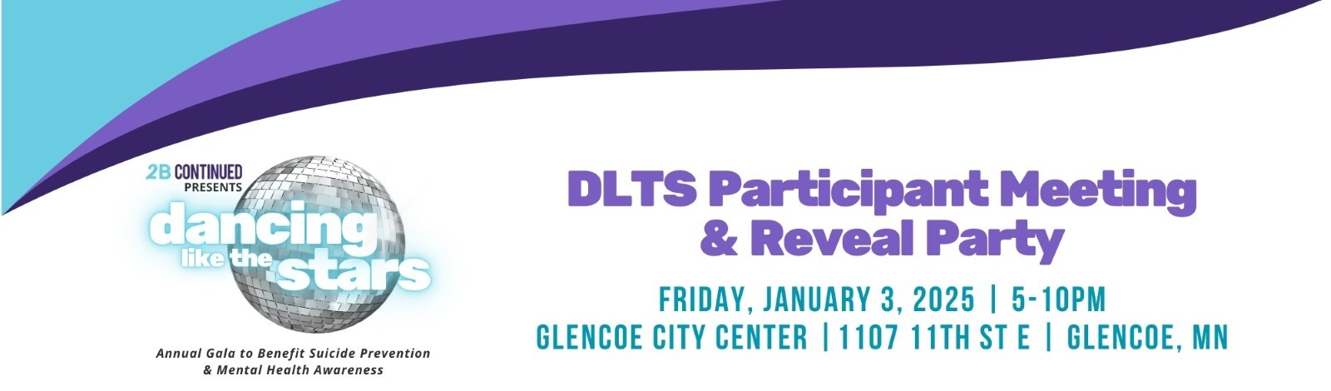

[Remove this line before use – Form Title: 2025 Electronic Donation Letter Template]

Dear [Insert NAME of Potential Donor ie. Business Owner, Civic Organization, Family Member or Friend],

We are so excited to be participating as a STAR Dance Couple in 2B CONTINUED’s 5th annual - ’25 Dancing Like The Stars (DLTS) Show, a friendly dance competition to benefit suicide prevention and mental health awareness, on Saturday, April 12, 2025, at the Glencoe City Center.

The pre-event fundraising competition is already underway. We would greatly appreciate your VOTES with a tax-deductible donation! $1=1 vote, $5=5 votes, etc.

Several options are available to VOTE:

1. **Become a Donorship Level Partner**: Visit: [2025 Donorship Brochure](https://www.2bcontinued.org/donorship/) to learn about this option. Fill out and return the sponsorship form as soon as possible. The form can be found at: [2025 Donorship Submission Form](https://www.2bcontinued.org/wpcontent/uploads/2024/12/2025CORPORATEDONORSHIP_form_FINAL.pdf) **(Form must be received by March 31, 2025 to meet publication deadline).**
2. **Donate with credit card**: [25 DLTS Leaderboard Campaign Page](https://www.betterunite.com/2bcontinued-25dltsleaderboard)- scroll down to find us and click on our campaign!
3. **Donate with a check:** (make payable to 2B CONTINUED). You can give it to us or mail to: PO Box 24, Glencoe, MN 55336. Write [COUPLE’S LAST NAME] in memo field of the check.

Every bit will help us reach our goal to raise $10,000 or more in support of this worthy cause. 2BC must receive your donation by April 11, 2024, at 6pm, to count as VOTES for us in the pre-event fundraising competition.

We would also LOVE to have you see our dance moves and cheer for us at the SHOW! You can buy Show Tickets at: [25 DLTS Show Tickets](https://www.betterunite.com/2bcontinued-25dlts-showtickets). With little to no dance experience, we have our work cut out for us! 2BC has paired us with a choreographer to learn our dance, so we are in good hands and up for the challenge! You won’t want to miss the opportunity to see this exceptional production and support this local organization doing critical work in our communities.

The DLTS Show is 2BC’s signature fundraising event and serves as the organization’s primary funding source. The money raised is used for education, outreach, and events in local communities to help carry out the mission.  In 2024, more than 40,000 people were impacted by 2BC’s programming.  You can view the full 2024 Impact Report at: [2024 Annual Impact Report](https://www.2bcontinued.org/impactreport/).

As featured by [Boyd Huppert on Land of 10,000 Stories](https://youtu.be/ioDXO2STqSE), their biggest program is Teen Mental Health First Aid (tMHFA). 2BC certified instructors go into schools to teach the tMHFA curriculum to high schoolers in 20 area school districts:

* BOLD
* Buffalo Lake-Hector-Stewart
* Central (NYA)
* Eden Valley Watkins
* Gibbon-Fairfax-Winthrop
* Glencoe – Silver Lake
* Hutchinson
* Howard Lake-Waverly-Winsted
* Lester Prairie
* LeSueur-Henderson
* Mayer Lutheran
* New Ulm Cathedral
* Nicollet
* Renville County West
* St. Peter
* Sibley East
* Sleepy Eye
* Springfield
* Waconia
* Watertown-Mayer

Each school has between 1-10 class sections, overall, there are 80 sections of students. The program costs about $2,500 per section to teach up to 30 students. It is offered without charge to schools, removing any financial barrier to participation. The response from schools and participants has been overwhelmingly positive.

Teuby Continued, dba 2B CONTINUED, (2BC) is a local 501c3 nonprofit organization (Fed. Tax ID# 84-2398238). They strive to increase awareness of suicide prevention, mental health, and wellness through advocacy, education, and outreach. Their primary service area includes 8-counties: Brown, Carver, McLeod, Meeker, Nicollet, Renville, Sibley, and Wright.

For more information, contact 2BC at [info@2bcontinued.org](mailto:info@2bcontinued.org) or (320) 854-HOPE (4673). Please note: 2BC does not offer any professional services. **If you or someone you know is in crisis, call, text, or chat 988.**

Thank you so much for your consideration and support! Together WE CAN Make A Difference!

[Your Names]

[Your Contact Info]